**MINI PROJECT REPORT ON**

**“Tasty Town – UI/UX Design Prototype using Figma”**

Submitted By

SHILADITTA RAJBANSHI

UID- 22MCI10259



**Under The Guidance of:**

**Mr. Shivam Sharma**

HUMAN COMPUTER INTERFACE

**April, 2025**

**University Institute of Computing**

**Chandigarh University,**

**Mohali, Punjab**

**CERTIFICATE**

This is to certify that SHILADITTA RAJBANSHI (UID- 22MCI10259) have successfully completed the project **“Tasty Town – UI/UX Design Prototype using Figma”** at University Institute of Computing under my supervision and guidance in the fulfilment of requirements of fourth semester,

**Master of Computer Application- Specialization in ARTIFICIAL INTELLIGENCE AND MACHINE LEARNING.** Of Chandigarh University, Mohali, Punjab.

|  |  |
| --- | --- |
| Dr. KRISHAN TULI | Mr. Shivam sharma |
| Head of the Department | Project Guide Supervisor |
| University Institute of Computing | University Institute of Computing |

**Acknowledgement**

I take this opportunity to express my sincere gratitude to all those who supported me throughout the development of this mini project, **"Tasty Town – UI/UX Design Prototype using Figma."**

First and foremost, I extend my heartfelt thanks to Mr. **Shivam sharma** , my project guide, for their invaluable guidance, support, and encouragement throughout this project. Their suggestions and constructive feedback were instrumental in shaping this report and the prototype effectively.

I would also like to thank the **Head of Department, Dr. krishan Tuli**, for providing the necessary facilities and an academic environment that helped in the successful completion of this work.

A special note of appreciation goes to our faculty members and lab assistants for their assistance and insightful input during the review sessions.

I am also grateful to my peers and friends for their constant motivation and valuable feedback during various phases of this project.

Last but not least, I would like to thank my family for their unwavering support, encouragement, and patience throughout my academic journey.

This project has been a great learning experience, and I am thankful for the opportunity to explore creative design processes using **Figma** in a real-world context.

**Shiladitta rajbanshi**  
**Roll No.: 23MCI10259**  
Date: ___________  
Place: ___________

**Abstract**

In today’s digital era, user interface (UI) and user experience (UX) design play a critical role in defining the success of any application. This project titled **“Tasty Town – UI/UX Design Prototype using Figma”** presents a comprehensive design exploration for a food delivery application, developed using modern UI/UX principles and prototyped through Figma.

The main objective of this mini project is to demonstrate effective wireframing, component-based design, responsive layout planning, and user interaction techniques. The project integrates six essential design experiments focused on usability principles, visual hierarchy, control components, interaction feedback, color theory, and multimodal search UI.

Key features of this prototype include a structured navigation system, visually appealing home screen, clear typography, color contrast optimized for accessibility, interactive elements like drag-and-drop, resizable panels, and a comprehensive search interface with filters and preview results. These elements were implemented while ensuring adherence to core UI/UX design principles like visibility, feedback, affordance, consistency, and error prevention.

The use of **Figma** as a tool enabled collaborative designing, real-time feedback implementation, and effective prototyping. The final design also includes multiple screens and windows such as modals, palette tools, and advanced filter-based search, making the interface both modern and intuitive.

This project not only aims to showcase creative design capability but also to bridge the gap between concept and interaction through practical Figma experiments aligned with real-world design standards.

**INDEX**

|  |  |
| --- | --- |
| Chapter Title / Section | Page |
| Certificate | **i** |
| Acknowledgement | **ii** |
| Abstract | **iii** |
| Index (Table of Contents) | **iv** |
| 1. Introduction & Project Background | **1** |
| 2. Objective, Scope & Design Principles | **2** |
| 3. UI Design Implementation Using Figma | **4** |
| 4. Components, Controls & Prototyping | **7** |
| 5. Final Mockups, Search UI & Accessibility | **9** |
| 6. Conclusion, Challenges & Future Scope | **11** |
| 7. Screenshots & Wireframes (Visual Gallery) | **13–14** |
| 8. References & Appendix | **15** |

**1. Introduction**

In today's digital world, the need for visually engaging and user-centric applications is more critical than ever. Whether it's a mobile app or a web interface, users expect intuitive navigation, responsive design, and visually appealing layouts that enhance their experience. This is especially important in the food delivery and browsing domain, where customers interact with a variety of visual elements, filters, search options, and product interfaces.

The mini project titled "Tasty Town" aims to address these demands by designing a comprehensive food-related application using Figma, a powerful browser-based UI/UX design tool. Figma allows for real-time collaboration, fast prototyping, and efficient component creation — making it ideal for building scalable and adaptive user interfaces.

The primary motivation behind this project is to apply theoretical knowledge of UI/UX design principles in a practical, tool-based implementation. By focusing on aspects like visual consistency, affordance, feedback mechanisms, readability, and accessibility, this project demonstrates how even a conceptual application can be brought to life using thoughtful design strategies.

The app includes features like:

* A structured home screen with engaging visuals and clean layout.
* Clear navigation flow with a top bar and bottom controls.
* Usable and scalable UI components (buttons, sliders, dropdowns, search).
* Interactive mockups to simulate real-time user journeys.
* An advanced search system with filters and multimodal content handling.

Through this mini project, the core objective is to explore how designers can elevate digital experiences through intentional design backed by user behavior insights. This report serves as both a documentation of the design process and a case study on applying good UI/UX practices using Figma.

**Introduction**

In today's digital world, the need for visually engaging and user-centric applications is more critical than ever. Whether it's a mobile app or a web interface, users expect intuitive navigation, responsive design, and visually appealing layouts that enhance their experience. This is especially important in the food delivery and browsing domain, where customers interact with a variety of visual elements, filters, search options, and product interfaces.

The mini project titled **"Tasty Town"** aims to address these demands by designing a comprehensive food-related application using **Figma**, a powerful browser-based UI/UX design tool. Figma allows for real-time collaboration, fast prototyping, and efficient component creation — making it ideal for building scalable and adaptive user interfaces.

The primary motivation behind this project is to apply theoretical knowledge of UI/UX design principles in a practical, tool-based implementation. By focusing on aspects like **visual consistency, affordance, feedback mechanisms, readability, and accessibility**, this project demonstrates how even a conceptual application can be brought to life using thoughtful design strategies.

The app includes features like:

* A structured **home screen** with engaging visuals and clean layout.
* Clear **navigation flow** with a top bar and bottom controls.
* Usable and scalable **UI components** (buttons, sliders, dropdowns, search).
* Interactive mockups to simulate real-time user journeys.
* An advanced **search system** with filters and multimodal content handling.

Through this mini project, the core objective is to explore how designers can elevate digital experiences through intentional design backed by user behavior insights. This report serves as both a documentation of the design process and a case study on applying good UI/UX practices using Figma.

**Objective, Scope & Design Principles**

**Objective**

The goal of this mini project was to design a functional and visually engaging user interface for a food delivery application named **Tasty Town**, using Figma. The focus was on crafting an intuitive user experience that emphasizes accessibility, responsiveness, and clarity. The project aimed to explore modern UI/UX practices while also offering hands-on experience in using Figma’s features like prototyping, components, and interactive controls.

**Scope**

This project is limited to the design phase of the application, specifically the user interface. It includes layout planning, component creation, and prototyping within Figma. Key inclusions are wireframes, mockups, typography styling, a color palette system, a search interface with filters, and visual interaction design. No coding or backend development was included in the scope.

**Design Principles**

To maintain consistency and usability across the app, several core design principles were followed:

* **Consistency**: Uniform layout, spacing, and visual styling.
* **Feedback**: Button hover states and input cues enhance user awareness.
* **Visibility**: Key actions and elements are highlighted and easy to identify.
* **Affordance**: Controls visually indicate their purpose (e.g., buttons look clickable).
* **Error Prevention**: Forms and filters limit invalid interactions.

These principles ensured a user-centric design aligned with modern standards.

**UI Design Implementation Using Figma**

The UI for *Tasty Town* was created entirely within Figma, utilizing its advanced layout, prototyping, and collaboration tools. The design process began with basic wireframes, followed by detailed mockups and interactive elements to simulate a real application experience.

**Figma Setup and Tools Used**

The project file was organized into multiple frames for different screens such as Home, Search, Filters, and Item Details. Figma’s component system allowed for reusable buttons, headers, cards, and icons—improving design consistency across the app.

Plugins used included:

* **Stark** – for checking contrast and accessibility.
* **Unsplash** – for quickly inserting high-quality images.
* **Icons8** – for importing modern vector icons.

Figma’s real-time collaboration helped in quickly testing ideas and refining layouts.

**Layout and Grids**

Grids and auto-layouts were used to maintain alignment and spacing across different device resolutions. The design was kept responsive by using flexible containers and alignment options.

**Interactivity**

Figma's prototyping tools helped in simulating user journeys:

* Click-through prototypes for navigation.
* Hover and press states for buttons.
* Scroll groups for dynamic content display.

This phase formed the core of the design execution, turning static ideas into interactive visuals.

**Components, Controls & Prototyping**

This section focused on building reusable UI elements and incorporating interactive controls that simulate a real app experience. Components were designed to ensure visual consistency and reduce repetitive tasks during development.

**Component System in Figma**

Figma components were used for:

* **Buttons** – Primary, secondary, icon-based, and disabled states.
* **Navigation Bar** – Fixed header with icons for Home, Search, and Profile.
* **Cards** – Displaying restaurant previews, food items, and ratings.
* **Forms & Input Fields** – Search bar, login fields, and feedback forms.
* **Pop-ups & Modals** – For alerts and quick actions.

Each component was built using Auto Layout and was responsive across different screen sizes.

**Control Types Implemented**

* **Device-Based Controls**: Tap buttons and scroll views designed for mobile touchscreens.
* **Text Entry & Read-Only**: Search bars, disabled input fields, and data previews.
* **Selection Controls**: Toggle switches, checkboxes (for dietary filters), and dropdowns.
* **Combined Controls**: Combo boxes used in search filters (e.g., “Sort by”).
* **Presentation Controls**: Progress indicators, image sliders, and star-rating views.

**Prototyping Interactions**

Interactive flows were created using:

* **Navigation links** between screens.
* **Overlays and transitions** for modals.
* **Animated transitions** (slide-in/slide-out) to simulate real mobile interactions.

Prototyping was critical in testing the user flow, verifying usability, and refining features based on feedback.

**Final Mockups, Search UI & Accessibility**

This part showcases the final refined designs of the application, including core screens, search functionalities, and accessibility considerations. The visual mockups represent how the app would appear and function on a real device, highlighting the effectiveness of design iterations.

**Final UI Mockups**

The final mockups included:

* **Home Screen**: Highlighting top-rated restaurants and categories.
* **Menu/Item Page**: Scrollable list with pricing, photos, and filters.
* **Profile & Settings**: User preferences, theme switcher, and order history.
* **Cart & Checkout**: Clean layout with CTA buttons and payment method selection.

**Search Interface Design**

Search functionality was a major feature:

* **Auto-suggest Search Bar**: Displaying top search results as users type.
* **Advanced Filters**: Based on cuisine, distance, price range, and ratings.
* **Boolean Logic**: "AND/OR" phrase search was represented via dropdowns.
* **Multimodal Results Display**:
  + Text entries (restaurant descriptions)
  + Image thumbnails (popular dishes)
  + Ratings & icons (vegan, spicy, fast delivery)

**Accessibility Features**

To ensure inclusivity:

* **High Color Contrast** was maintained using tools like Stark.
* **Font Sizes** followed accessibility standards for readability.
* **Keyboard Navigation Compatibility** was tested via prototype simulations.
* **Icons** included alt-text in descriptions for screen reader support.

The design aimed to be user-friendly for both general and visually impaired users.

**Conclusion, Challenges & Future Scope**

**Conclusion**

The 'Tasty Town' UI/UX project successfully demonstrated how Figma can be used to build an intuitive, visually pleasing, and accessible food delivery app. Through structured planning and adherence to key design principles, the prototype reflects real-world usability with engaging components, organized layouts, and responsive user flow.

This project helped bring together theoretical design guidelines and practical implementation, emphasizing user-centric solutions. The final output includes detailed wireframes, interactive mockups, a search system with multimodal results, and accessibility considerations. Overall, the app offers a seamless experience from browsing to checkout.

**Challenges Faced**

While designing, several challenges emerged:

* **Design Consistency**: Maintaining a uniform look across all screens was demanding, especially during component reuse.
* **Balancing Aesthetics with Usability**: Integrating graphics without overwhelming the user took repeated revisions.
* **Implementing Search Logic Visually**: Translating Boolean logic and multimodal results into simple visual design required creative UI thinking.
* **Time Constraints**: Finalizing all aspects—from layout to accessibility—within limited time was intense.

These obstacles encouraged thoughtful problem-solving and better time management during the project phases.

**Future Scope**

With more time and resources, the design could be expanded with:

* **Real-time Prototyping** using micro-interactions and transitions.
* **Integration of AI** for personalized recommendations and chatbot assistance.
* **Dark Mode & Theming Options** for better user personalization.
* **Multi-language Support** to increase accessibility for regional users.

The project serves as a strong foundation for a potential full-scale app development cycle.

**Screenshots & Wireframes (Visual Gallery)**

This section presents the visual output of the ‘Tasty Town’ UI/UX project, created entirely using Figma. It includes wireframes, mockups, and component layouts that reflect the design process from low-fidelity wireframes to high-fidelity prototypes.

**Wireframes**

The wireframes establish the structural skeleton of the app interface. These include:

* **Home Screen Layout**: Placement of food categories, banners, and search bar.
* **Navigation Bar**: Icons for Home, Orders, Favorites, and Profile.
* **Food Item Page**: Sections for images, prices, ratings, and Add to Cart button.
* **Cart Overview**: A simplified layout to quickly view, edit, or proceed to checkout.

These wireframes followed a grid-based structure ensuring alignment and responsiveness.

**UI Screens (High-Fidelity Mockups)**

The final mockups use the selected color scheme, icons, and typography to create polished, interactive UI designs. Highlights include:

* **Login & Registration Pages**: Clean, minimal UI for quick onboarding.
* **Category-Based Navigation**: Smooth transitions between food categories.
* **Filters & Search**: Advanced filter options like cuisine, price, and ratings.
* **Auto-suggestion in Search Bar**: Smart suggestions based on typed input.
* **Checkout Flow**: Multi-section view including address, payment, and delivery options.

**Component Screens**

This section includes views of designed components such as:

* Buttons with hover states and color feedback.
* Custom toggles, dropdowns, checkboxes, and input fields.
* Table-style order summary with dynamic quantity controls.

These visuals reinforce usability, hierarchy, and accessibility of the interface.

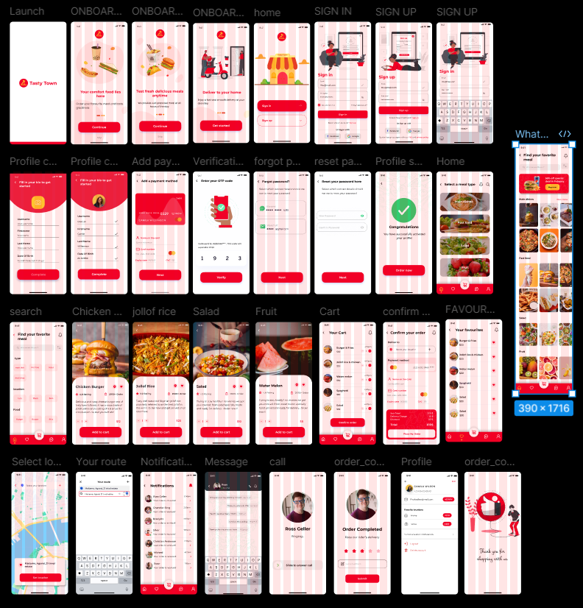

**References & Appendix**

**References**

The following resources were referred to during the course of the UI/UX design and implementation in Figma:

1. **Material Design Guidelines** – https://m3.material.io/  
   For structuring consistent components, elevation, color, and responsiveness.
2. **Figma Documentation** – https://help.figma.com  
   Used for mastering features such as components, prototyping, auto-layouts, and plugins.
3. **Color Theory in UI Design** – Adobe Color & WebAIM Contrast Checker  
   Tools for accessible color palettes, contrast verification, and visual harmony.
4. **Interaction Design Principles** – Don Norman’s "The Design of Everyday Things"  
   For understanding affordances, feedback, constraints, and conceptual models.
5. **Accessible UX Design** – Stark Plugin for Figma  
   Ensured that the interface meets accessibility standards including contrast and readability.

**Appendix**

* **Figma Prototype Link (URL/QR Code)**  
  [Your prototype Figma link here – replace with actual URL]  
  *Scan or click to interact with the live prototype.*
* **Plugin Tools Used**:
  + Stark (Accessibility contrast checker)
  + Iconify (for icons)
  + Unsplash (free image assets)
* **Fonts Used**:
  + Headings: Montserrat Bold
  + Body Text: Roboto Regular
* **Color Palette**:
  + Primary: #FF6B00 (Warm Orange)
  + Accent: #FFD166 (Light Yellow)
  + Background: #FFF8F0
  + Text: #2D2D2D